**FURNIRUL**

**ce este si de cate tipuri**

Furnirul este de doua tipuri principale si anume, furnirul estetic cu rol de a innobila placa suport si furnirul tehnic, cu rol principal de rezistenta si echilibrare a placii, insa cum este cazul mesteacanului poate ave asi rol de furnir estetic. O a treia categorie de furnire, recent aparuta, este furnirul reconditionat sau furnirul tehnologic folosit ca furnir de balans, la spatele placilor, respectiv la partile de mobilier mai putin vizibile.

* **FURNIR ESTETIC** care de regula este produs din lemn de valoare ridicata, cum ar fi: de stejar, cires, ulm, frasin, wenge etc. sau specii lemnoase ceva mai ieftine ca teiul, fagul, mesteacanul etc.
* furnirul estetic se obtine printr-o tehnologie diferita de cel ethnic si anume prin felierea partilor de bustean;
* culoarea lemnului, respectiv a furnirelor difera de la un arbore la altul sau mai mult, de la o statiune forestiera la alta, desenul lemnului dat de conformatia de crestere si din acest motiv abalarea se face pe un singur pachet sau un singur palet de furnire obtinute din acelasi bustean;
* lungimea furnirului estetic poate varia, insa de regula este putin mai mare decat standardul placilor support, 2000, 2440 sau 2500 mm pt. placaj si 2800 sau chiar 3660 mm pentru MDF sau PAL
* grosimea furnirului estetic este de regula de 0.6-0.7 mm
* imbinarea furnirelor pe placa suport se face prin lipire in cant cu utilaje de mare precizie sau cu fir fuzibil;
* lipirea furnirelor de placile support se face de regula cu adeziv de interior, destinatia lor proncipala fiind industria producatorilor de mobila;
* exista 3 tipuri de taiere a furnirelor estetice si anume:

**taiere tangentiala -** cand busteanul este fixat in utilaj si bratul cu cutitul de taiere culiseaza tangential pe

bustean

[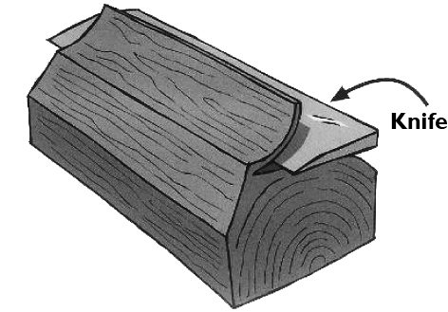](http://www.losanbenelux.nl/img/veneer/dosse.jpg)

**taiere perpendiculara pe inelele de crestere** – busteanul este fixat si cutitul culiseaza perpendicular pe inelele de crestere pe o piesa extrasa din bustean, rezultatul este furnirul friz, cu liniile desenului paralele

[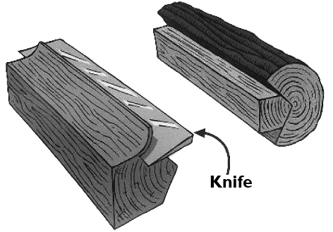](http://www.losanbenelux.nl/img/veneer/kwartier.jpg)

**taiere prin derulare -** busteanul este fixat la capete intr-un dispozitiv rotative si cutitul apasa constant tangential pe bustean, rezultatul fiind un covor continuu de furnire cu fladere, tehnoligie utilizata in special la obtinerea furnirelor tehnice, de 1.4 mm grosime in cazul mesteacanului, arinului etc., 2.0 - 2.5 mm grosime in cazul plopului, fagului etc., 2.8 – 3 – 3.5 mm grosime in cazul pinului sau esentelor exotice moi

[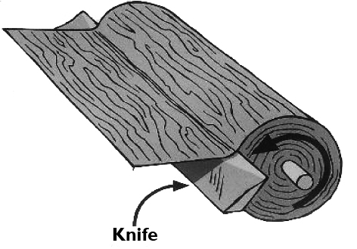](http://www.losanbenelux.nl/img/veneer/afrol.jpg)

* exista 3 tipuri de aranjare a furnirelor estetice pe placa suport, in vederea lipirii lor si anume:

**in oglinda sau ca paginile unei carti**

[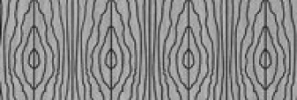](http://www.losanbenelux.nl/img/veneer/boek.jpg)

**la rand,** cand furnirele sunt luate din pachet si aranjate fara sa li se modifice pozitia

[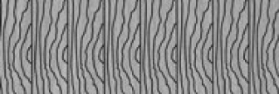](http://www.losanbenelux.nl/img/veneer/geschoven.jpg)

**aleatoriu,** cand furnire din diverse pachete sunt aranjate aleatoriu, obtinandu-se astfel un effect de placa din lemn masiv

[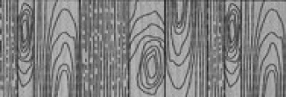](http://www.losanbenelux.nl/img/veneer/massief.jpg)

**COLECTIILE DE FURNIRE DISPONIBILE**

# NATURALS

[[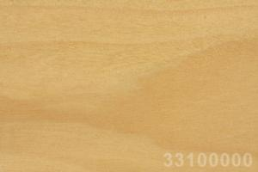](http://www.losanbenelux.nl/index.cfm?category=naturals&item=33100000)](http://www.losanbenelux.nl/index.cfm?category=naturals&item=33100000)

Anegre, crown cut

[[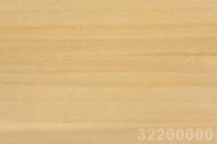](http://www.losanbenelux.nl/index.cfm?category=naturals&item=33200000)](http://www.losanbenelux.nl/index.cfm?category=naturals&item=33200000)

Anegre, quarter cut

[[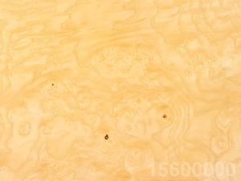](http://www.losanbenelux.nl/index.cfm?category=naturals&item=15600000)](http://www.losanbenelux.nl/index.cfm?category=naturals&item=15600000)

Ash, burl

[[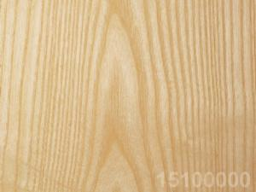](http://www.losanbenelux.nl/index.cfm?category=naturals&item=15100000)](http://www.losanbenelux.nl/index.cfm?category=naturals&item=15100000)

Ash, crown cut

[[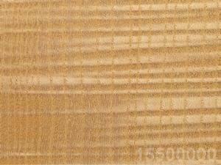](http://www.losanbenelux.nl/index.cfm?category=naturals&item=15500000)](http://www.losanbenelux.nl/index.cfm?category=naturals&item=15500000)

Ash, figured

[[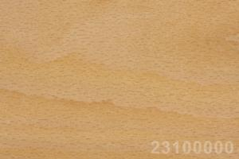](http://www.losanbenelux.nl/index.cfm?category=naturals&item=23100000)](http://www.losanbenelux.nl/index.cfm?category=naturals&item=23100000)

Beech, Steamed, crown cut

[[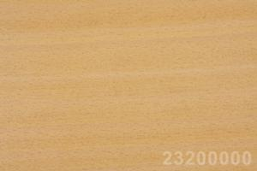](http://www.losanbenelux.nl/index.cfm?category=naturals&item=23200000)](http://www.losanbenelux.nl/index.cfm?category=naturals&item=23200000)

Beech, Steamed, quarter cut

[[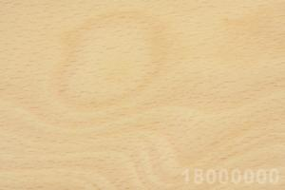](http://www.losanbenelux.nl/index.cfm?category=naturals&item=18000000)](http://www.losanbenelux.nl/index.cfm?category=naturals&item=18000000)

Beech, White, crown cut

[[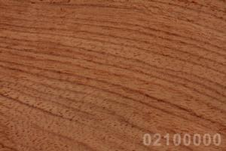](http://www.losanbenelux.nl/index.cfm?category=naturals&item=02100000)](http://www.losanbenelux.nl/index.cfm?category=naturals&item=02100000)

Bubinga

[[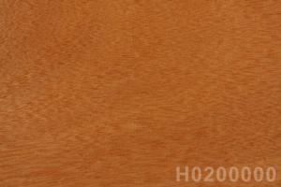](http://www.losanbenelux.nl/index.cfm?category=naturals&item=H0200000)](http://www.losanbenelux.nl/index.cfm?category=naturals&item=H0200000)

Cedar

[[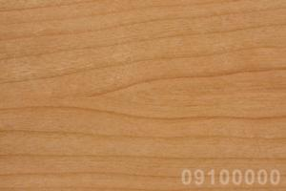](http://www.losanbenelux.nl/index.cfm?category=naturals&item=09100000)](http://www.losanbenelux.nl/index.cfm?category=naturals&item=09100000)

Cherry, American, quarter cut

[[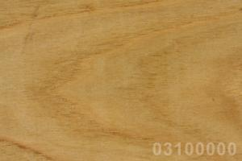](http://www.losanbenelux.nl/index.cfm?category=naturals&item=03100000)](http://www.losanbenelux.nl/index.cfm?category=naturals&item=03100000)

Chestnut, crown cut

[[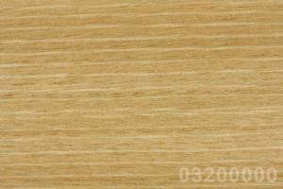](http://www.losanbenelux.nl/index.cfm?category=naturals&item=03200000)](http://www.losanbenelux.nl/index.cfm?category=naturals&item=03200000)

Chestnut, quarter cut

[[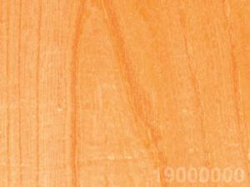](http://www.losanbenelux.nl/index.cfm?category=naturals&item=19000000)](http://www.losanbenelux.nl/index.cfm?category=naturals&item=19000000)

Elm

[[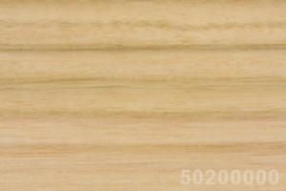](http://www.losanbenelux.nl/index.cfm?category=naturals&item=50200000)](http://www.losanbenelux.nl/index.cfm?category=naturals&item=50200000)

Eucalyptus, quarter cut

[[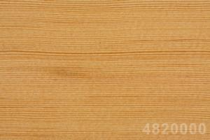](http://www.losanbenelux.nl/index.cfm?category=naturals&item=48200000)](http://www.losanbenelux.nl/index.cfm?category=naturals&item=48200000)

Fir, Douglas (= Oregon Pine)

[[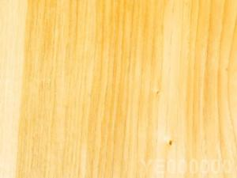](http://www.losanbenelux.nl/index.cfm?category=naturals&item=YE000000)](http://www.losanbenelux.nl/index.cfm?category=naturals&item=YE000000)

Hickory

[[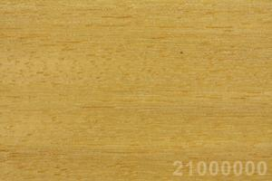](http://www.losanbenelux.nl/index.cfm?category=naturals&item=21000000)](http://www.losanbenelux.nl/index.cfm?category=naturals&item=21000000)

Iroko

[[](http://www.losanbenelux.nl/index.cfm?category=naturals&item=G0000000)](http://www.losanbenelux.nl/index.cfm?category=naturals&item=G0000000)

Koto

[[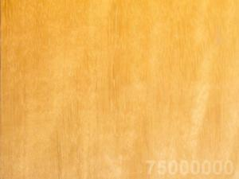](http://www.losanbenelux.nl/index.cfm?category=naturals&item=75000000)](http://www.losanbenelux.nl/index.cfm?category=naturals&item=75000000)

Limba

[[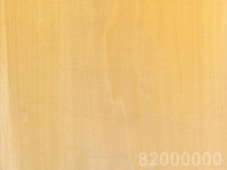](http://www.losanbenelux.nl/index.cfm?category=naturals&item=82000000)](http://www.losanbenelux.nl/index.cfm?category=naturals&item=82000000)

Lime tree

[[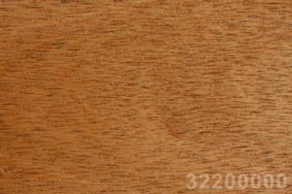](http://www.losanbenelux.nl/index.cfm?category=naturals&item=32200000)](http://www.losanbenelux.nl/index.cfm?category=naturals&item=32200000)

Mahogany, African, crown cut

[[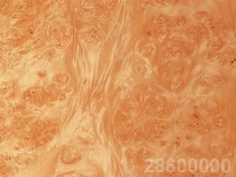](http://www.losanbenelux.nl/index.cfm?category=naturals&item=28600000)](http://www.losanbenelux.nl/index.cfm?category=naturals&item=28600000)

Maple, American, burl

[[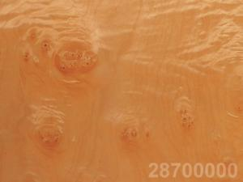](http://www.losanbenelux.nl/index.cfm?category=naturals&item=28700000)](http://www.losanbenelux.nl/index.cfm?category=naturals&item=28700000)

Maple, American, cluster

[[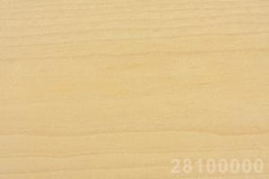](http://www.losanbenelux.nl/index.cfm?category=naturals&item=28100000)](http://www.losanbenelux.nl/index.cfm?category=naturals&item=28100000)

Maple, American, crown cut

[[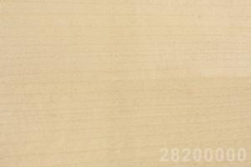](http://www.losanbenelux.nl/index.cfm?category=naturals&item=28200000)](http://www.losanbenelux.nl/index.cfm?category=naturals&item=28200000)

Maple, American, quarter cut

[[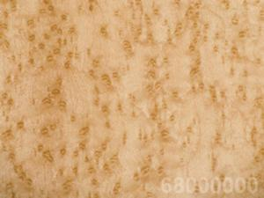](http://www.losanbenelux.nl/index.cfm?category=naturals&item=68000000)](http://www.losanbenelux.nl/index.cfm?category=naturals&item=68000000)

Maple, Bird's Eye

[[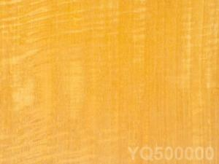](http://www.losanbenelux.nl/index.cfm?category=naturals&item=YQ500000)](http://www.losanbenelux.nl/index.cfm?category=naturals&item=YQ500000)

Movingui

[[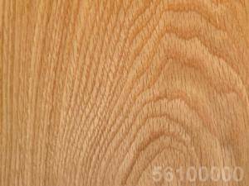](http://www.losanbenelux.nl/index.cfm?category=naturals&item=56100000)](http://www.losanbenelux.nl/index.cfm?category=naturals&item=56100000)

Oak, American White, crown cut

[[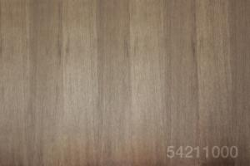](http://www.losanbenelux.nl/index.cfm?category=naturals&item=54211000)](http://www.losanbenelux.nl/index.cfm?category=naturals&item=54211000)

Oak, European, quarter cut

[[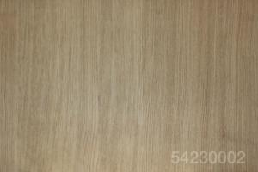](http://www.losanbenelux.nl/index.cfm?category=naturals&item=54230002)](http://www.losanbenelux.nl/index.cfm?category=naturals&item=54230002)

Europ. Oak Quarter Cut, mismatched

[[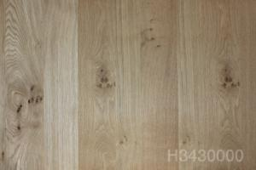](http://www.losanbenelux.nl/index.cfm?category=naturals&item=H3430000)](http://www.losanbenelux.nl/index.cfm?category=naturals&item=H3430000)

Knotty Oak, mismatched

[[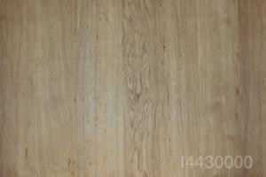](http://www.losanbenelux.nl/index.cfm?category=naturals&item=I4430000)](http://www.losanbenelux.nl/index.cfm?category=naturals&item=I4430000)

Oak, Pippy, mismatched

[[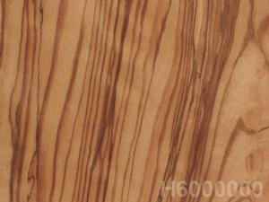](http://www.losanbenelux.nl/index.cfm?category=naturals&item=H6000000)](http://www.losanbenelux.nl/index.cfm?category=naturals&item=H6000000)

Olive

[[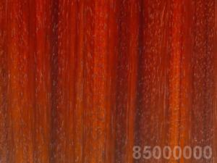](http://www.losanbenelux.nl/index.cfm?category=naturals&item=85000000)](http://www.losanbenelux.nl/index.cfm?category=naturals&item=85000000)

Padouk

[[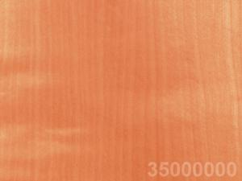](http://www.losanbenelux.nl/index.cfm?category=naturals&item=35000000)](http://www.losanbenelux.nl/index.cfm?category=naturals&item=35000000)

Pear tree

[[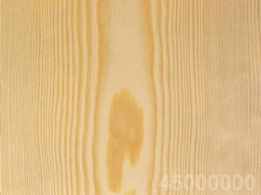](http://www.losanbenelux.nl/index.cfm?category=naturals&item=45000000)](http://www.losanbenelux.nl/index.cfm?category=naturals&item=45000000)

Pine

[[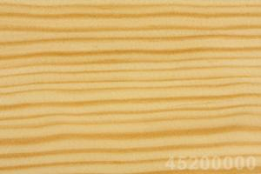](http://www.losanbenelux.nl/index.cfm?category=naturals&item=45200000)](http://www.losanbenelux.nl/index.cfm?category=naturals&item=45200000)

Pine, Galician, quarter cut

[[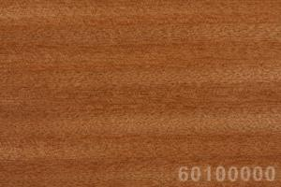](http://www.losanbenelux.nl/index.cfm?category=naturals&item=60100000)](http://www.losanbenelux.nl/index.cfm?category=naturals&item=60100000)

Sapele, quarter cut

[[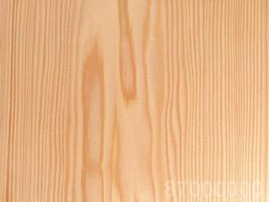](http://www.losanbenelux.nl/index.cfm?category=naturals&item=87000000)](http://www.losanbenelux.nl/index.cfm?category=naturals&item=87000000)

Spruce

[[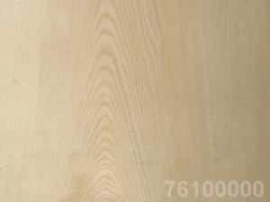](http://www.losanbenelux.nl/index.cfm?category=naturals&item=76100000)](http://www.losanbenelux.nl/index.cfm?category=naturals&item=76100000)

Sycomore (= European Maple)

[[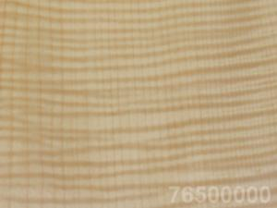](http://www.losanbenelux.nl/index.cfm?category=naturals&item=76500000)](http://www.losanbenelux.nl/index.cfm?category=naturals&item=76500000)

Sycomore (= European Maple) , figured

[[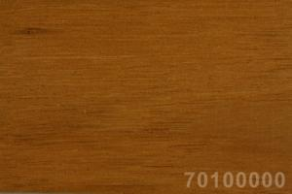](http://www.losanbenelux.nl/index.cfm?category=naturals&item=70100000)](http://www.losanbenelux.nl/index.cfm?category=naturals&item=70100000)

Teak

[[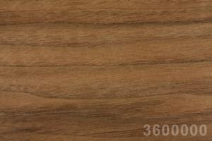](http://www.losanbenelux.nl/index.cfm?category=naturals&item=3600000)](http://www.losanbenelux.nl/index.cfm?category=naturals&item=3600000)

Walnut, American

[[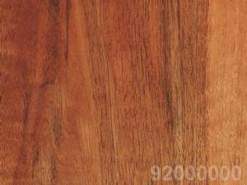](http://www.losanbenelux.nl/index.cfm?category=naturals&item=92000000)](http://www.losanbenelux.nl/index.cfm?category=naturals&item=92000000)

Walnut, European

[[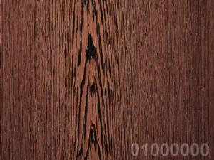](http://www.losanbenelux.nl/index.cfm?category=naturals&item=01000000)](http://www.losanbenelux.nl/index.cfm?category=naturals&item=01000000)

Wenge

# ADVANCED

[[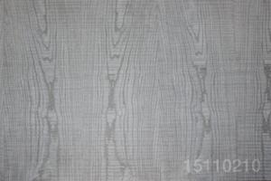](http://www.losanbenelux.nl/index.cfm?category=advanced&item=15110210)](http://www.losanbenelux.nl/index.cfm?category=advanced&item=15110210)

Ash, dyed ceniza, rough cut, mismatched

[[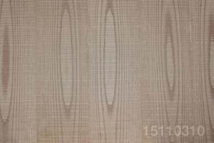](http://www.losanbenelux.nl/index.cfm?category=advanced&item=15110310)](http://www.losanbenelux.nl/index.cfm?category=advanced&item=15110310)

Ash, dyed avellana, rough cut

[[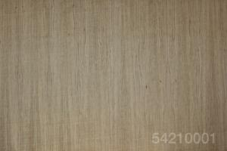](http://www.losanbenelux.nl/index.cfm?category=advanced&item=54110001)](http://www.losanbenelux.nl/index.cfm?category=advanced&item=54110001)

European Oak, scratched

[[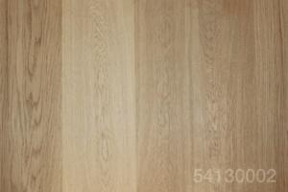](http://www.losanbenelux.nl/index.cfm?category=advanced&item=54130002)](http://www.losanbenelux.nl/index.cfm?category=advanced&item=54130002)

European Oak, mismatched, brushed

[[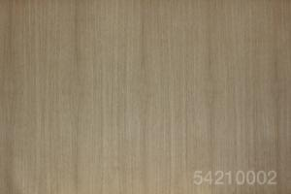](http://www.losanbenelux.nl/index.cfm?category=advanced&item=54210002)](http://www.losanbenelux.nl/index.cfm?category=advanced&item=54210002)

European Oak, brushed

[[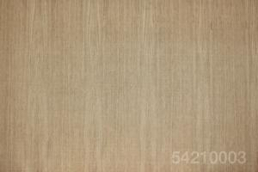](http://www.losanbenelux.nl/index.cfm?category=advanced&item=54210003)](http://www.losanbenelux.nl/index.cfm?category=advanced&item=54210003)

European Oak, brushed , scratched

[[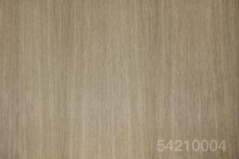](http://www.losanbenelux.nl/index.cfm?category=advanced&item=54210004)](http://www.losanbenelux.nl/index.cfm?category=advanced&item=54210004)

European Oak, TexTop

[[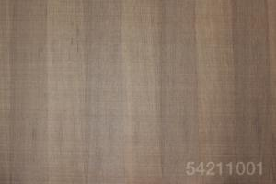](http://www.losanbenelux.nl/index.cfm?category=advanced&item=54211001)](http://www.losanbenelux.nl/index.cfm?category=advanced&item=54211001)

European Oak, quarter cut, book matched, scratched

[[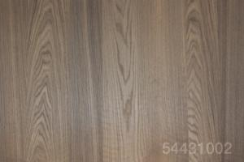](http://www.losanbenelux.nl/index.cfm?category=advanced&item=54431002)](http://www.losanbenelux.nl/index.cfm?category=advanced&item=54431002)

Smoked Oak, crown cut, mismatched

[[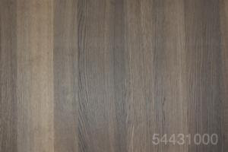](http://www.losanbenelux.nl/index.cfm?category=advanced&item=54431000)](http://www.losanbenelux.nl/index.cfm?category=advanced&item=54431000)

Smoked Oak, mismatched

[[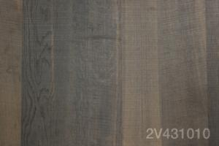](http://www.losanbenelux.nl/index.cfm?category=advanced&item=2V431010)](http://www.losanbenelux.nl/index.cfm?category=advanced&item=2V431010)

Smoked Oak,rough cut, mismatched

[[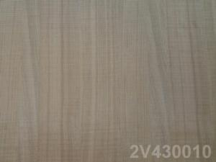](http://www.losanbenelux.nl/index.cfm?category=advanced&item=2V430010)](http://www.losanbenelux.nl/index.cfm?category=advanced&item=2V430010)

Rough Cut Oak, mismatched, without knots

[[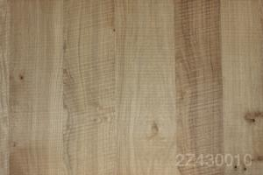](http://www.losanbenelux.nl/index.cfm?category=advanced&item=2Z430010)](http://www.losanbenelux.nl/index.cfm?category=advanced&item=2Z430010)

Rough Cut Oak, natural, mismatched, with knots

[[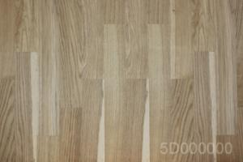](http://www.losanbenelux.nl/index.cfm?category=advanced&item=5D000000)](http://www.losanbenelux.nl/index.cfm?category=advanced&item=5D000000)

Oak, flooring look

[[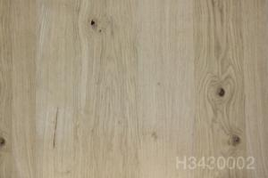](http://www.losanbenelux.nl/index.cfm?category=advanced&item=H3430001)](http://www.losanbenelux.nl/index.cfm?category=advanced&item=H3430001)

Knotty Oak, mismatched, brushed

[[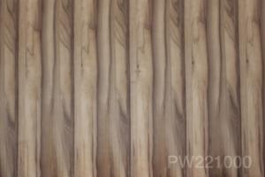](http://www.losanbenelux.nl/index.cfm?category=advanced&item=PW221000)](http://www.losanbenelux.nl/index.cfm?category=advanced&item=PW221000)

Satin Walnut, slipmatched